**INTRODUCTION**

The Attendance Management System Project in Java is software that is used in schools, universities, and institutes to track daily student attendance. It makes it easier to find out about a certain student’s attendance in a specific class. The data is sorted by the operators, who are provided by the teacher for a specific class. This approach will also assist in determining student’s attendance eligibility criteria**.**

Attendance management System is Java Swing project for tracking student’s attendance. Talking about the project, it contains an admin side and a user side where a user can view attendance. The admin plays an important role in the management of this system. In this project, the Admin user has to perform all the main functions from the admin side. This system is in NetBeans IDE and supports MySQL as backend.

**PURPOSE**

When a school uses an attendance management system, it can keep track of the exact arrival time of each student and automatically alert parents when a student is absent. As a teacher, you can keep track of your students’ attendance in class, report the reasons why they were absent, and let their parents know that they were absent.

The goal of creating an Attendance Management System in Java is to automate the traditional method of taking attendance. Another reason for creating this program was to be able to generate a bespoke report at the conclusion of the session or in the middle of it. Another objective for creating this project is to improve our ability to learn and apply what we’ve learned in the required area.

**OVERVIEW**

Attendance management system is a web application that will help to**manage the attendance of any Student or Employee in School, College or Organization.** Where the admin can add the user and faculty record and faculty can add the attendance for the student or employee.

There are multiple actors or users of the application they can access according to work. Like Admin, Faculty, and student.

**Admin:**

* Admin can ADD/EDIT/DELETE update the record of students or users.
* Admin can ADD/EDIT/DELETE update the record of faculty or teachers.
* Admin can view the record of all the students and teachers.
* Admin can manage own profile.
* Admin can enter the application after login with valid credentials only.

**Faculty or Teacher**

* Faculty can view the all the students.
* Faculty can ADD/EDIT/DELETE the subject and courses.
* Faculty can add attendance according to the class or courses.
* Faculty can view the attendance and can add the filter of the student who has attendance below 75%

**REQUIREMENTS**

* 1. Front end : Java Swing.
  2. Database :Mysql Database
  3. IDE Used : Netbeans 8.0

**PROPOSED SYSTEM**

The proposed Attendance Management System Project in Java using NetBeans should be user-friendly, with quick retrieval and storage of data and effective data management. Furthermore, the suggested system should provide a graphical user interface that allows users to interact with the system quickly. The proposed solution necessitates minimal paper work. All of the data is immediately entered into the computer, and reports can be made using computers. Furthermore, labor becomes much easier because data is no longer kept on paper

DISADVANTAGES OF PRESENT WORKING SYSTEM

* Difficulty in report generating: We require more calculations to generate the report so it is generated at the end of the session. And the student not get a single chance to improve their attendance
* Manual control: All calculations to generate report is done manually so there is greater chance of errors.
* Lots of paperwork: Existing system requires lot of paper work. Loss of even a single register/record led to difficult situation because all the papers are needed to generate the reports.
* Time consuming: Every work is done manually so we cannot generate report in the middle of the session or as per the requirement because it is very time consuming.

ADVANTAGES OF THE PROPOSED SYSTEM

* User Friendly: The proposed system is user friendly because the retrieval and storing of data is fast and data is maintained efficiently. Moreover the graphical user interface is provided in the proposed system, which provides user to deal with the system very easily.
* Reports are easily generated: reports can be easily generated in the proposed system so user can generate the report as per the requirement (monthly) or in the middle of the session. User can give the notice to the students so he/she become regular.
* The proposed system requires very less paper work.

**SNAPSHOTS**

**INPUT**

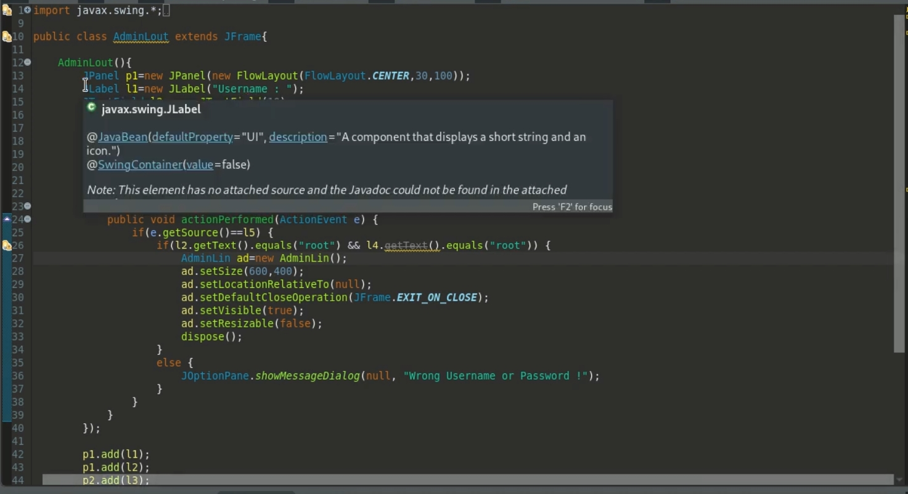

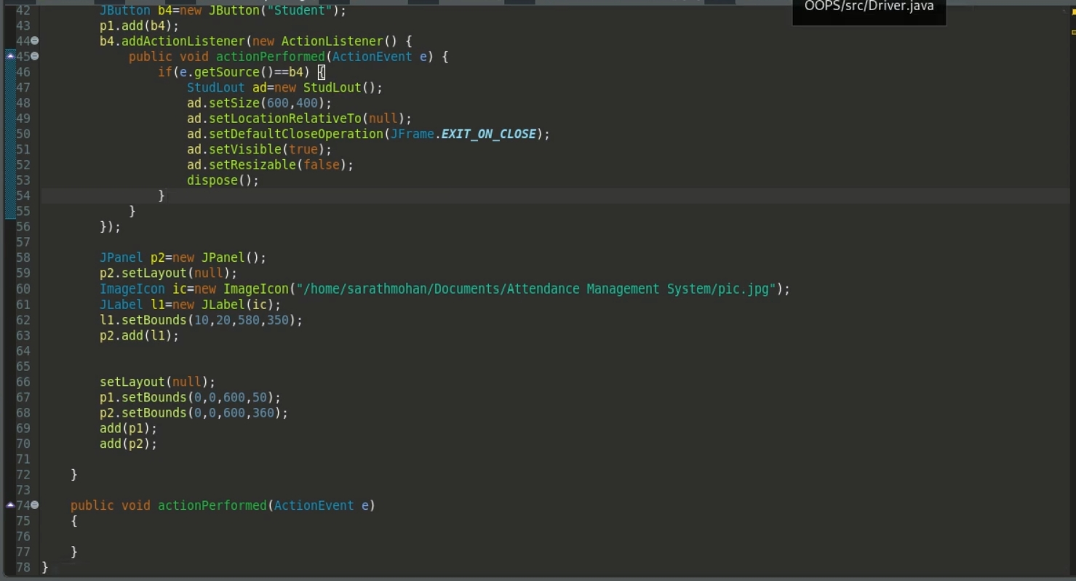

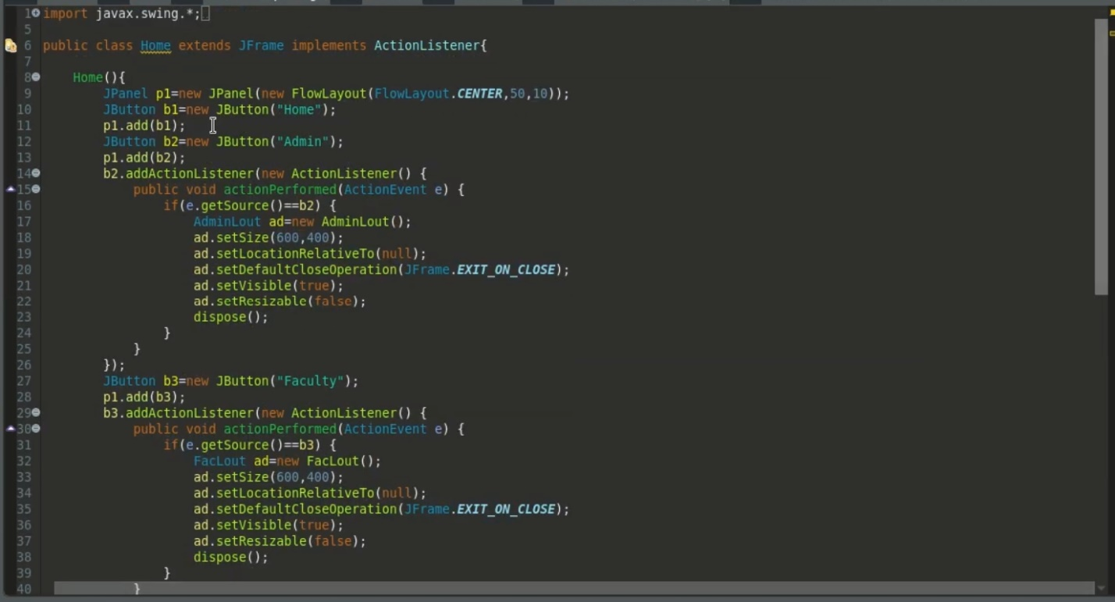

**OUTPUT**

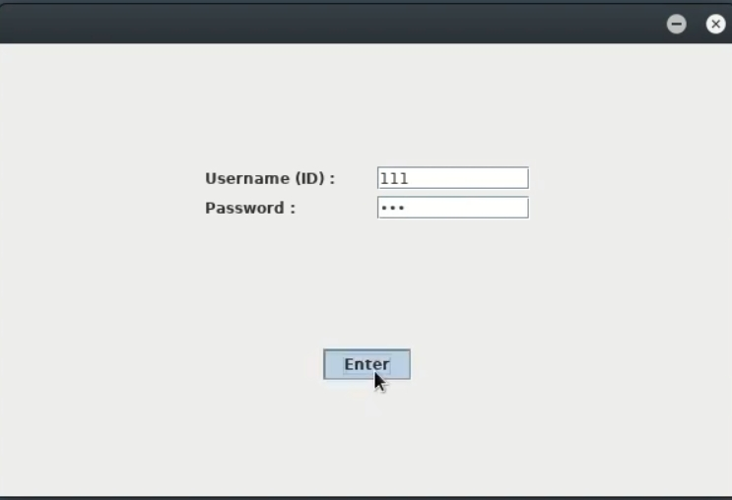

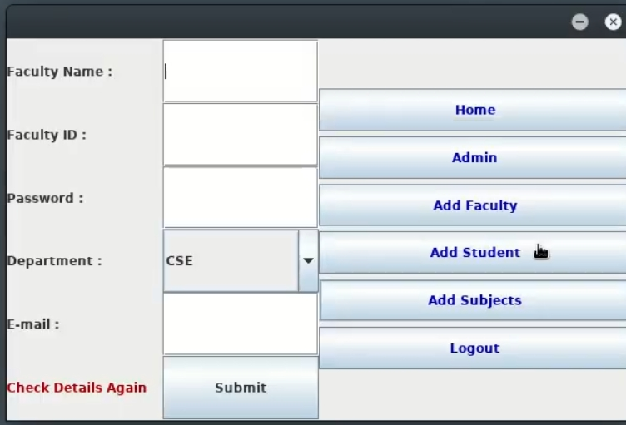

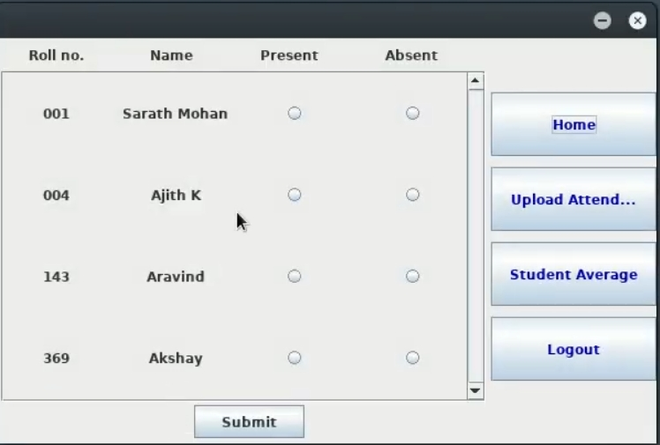

**CONCLUSION**

A good attendance management system can do a lot of things for you. This system makes your work easier and more efficient, and it also helps to avoid mistakes that could cost you money

It was a wonderful learning experience for me and my team while working on this project. This project gave us real insight into the world of software engineering.

**REFERENCE**

* 1. [**https://codebun.com/attendance-management-system-project-in-java-with-source-code-and-project-report/?ez_vid=32f1c66df4876d29388f1edd6a6ad97173fe28e0#ezoic-pub-video-placeholder-7**](https://codebun.com/attendance-management-system-project-in-java-with-source-code-and-project-report/?ez_vid=32f1c66df4876d29388f1edd6a6ad97173fe28e0#ezoic-pub-video-placeholder-7)
  2. [**https://projectworlds.in/attendance-management-system-java-mysql-netbeans-ide/#:~:text=Attendance%20management%20System%20is%20Java,the%20management%20of%20this%20system**](https://projectworlds.in/attendance-management-system-java-mysql-netbeans-ide/#:~:text=Attendance%20management%20System%20is%20Java,the%20management%20of%20this%20system)**.**
  3. [**https://sourcecodehero.com/attendance-management-system-project-in-java-with-source-code/**](https://sourcecodehero.com/attendance-management-system-project-in-java-with-source-code/)

.